跳转页面

<!DOCTYPE html>
<html>
<head>
<meta charset="UTF-8">
<title></title>

</head>
<body>
<div id="div"></div>
<a href="javascript:tz()">就是香花店</a>
</body>
<script type="text/javascript">
var i=5
function tz(){
document.getElementById("div").innerText =i+"秒后跳转"

if(i>0){
i--;
setTimeout('tz()', 1000)
}else if(i==0){
window.location='主页.html';

}

}
</script>
</html>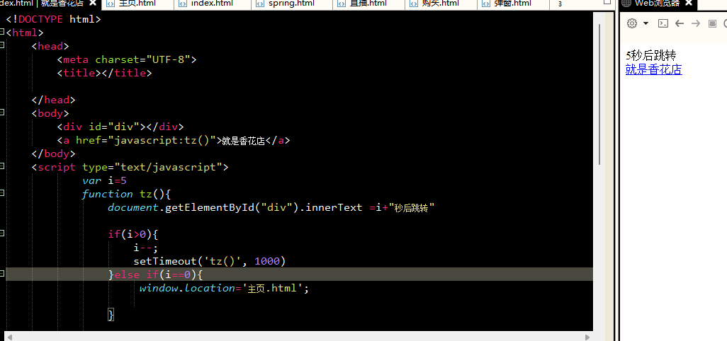

主页
<!DOCTYPE html>
<html>
<head>
<meta charset="UTF-8">
<title></title>
<style>
body{
margin: 0;
padding: 0;
}
#h_1,#h_2,#h_3{
width: 100%;
height: 150px;
border: 1px solid;
border-color:rgb(0, 47, 167);
}
.h_1{
background-image: url(img/KELAIYIN.jpg);
}
.h_2{
background-image: url(img/wanmei.png);

}
.h_3{
background-image: url(img/qiangwei.jpg);
background-size:230px
}
#h{
width: 150px;
height: 170px;
float: left;
margin: 10px 10px 10px 10px;
padding: 10px 10px 10px 10px;
}
a{
display: block;
text-align: center;
}
</style>
<script>
function sx(){
window.location.reload();
}
function fh(){
window.history.back()
}
</script>
</head>
<body>
<div id="hua">
<div id="h">
<div id="h_1" class="h_1"></div>
<a href="javascript:location='克莱因.html'" >查看详情</a>
</div>
<div id="h">
<div id="h_2" class="h_2"></div>
<a href="javascript:location='完美.html'" >查看详情</a>
</div>
<div id="h">
<div id="h_3" class="h_3"></div>
<a href="javascript:location='蔷薇.html'" >查看详情</a>
</div>
</div>
<br />
<table align="center" >
<tr>
<td>
<a href="javascript:sx()" >刷新</a>
</td>
<td>&nbsp;&nbsp;&nbsp;&nbsp;&nbsp;&nbsp;</td>
<td>
<a href="javascript:fh()">后退</a>
</td>
</tr>
</table>
</body>
</html>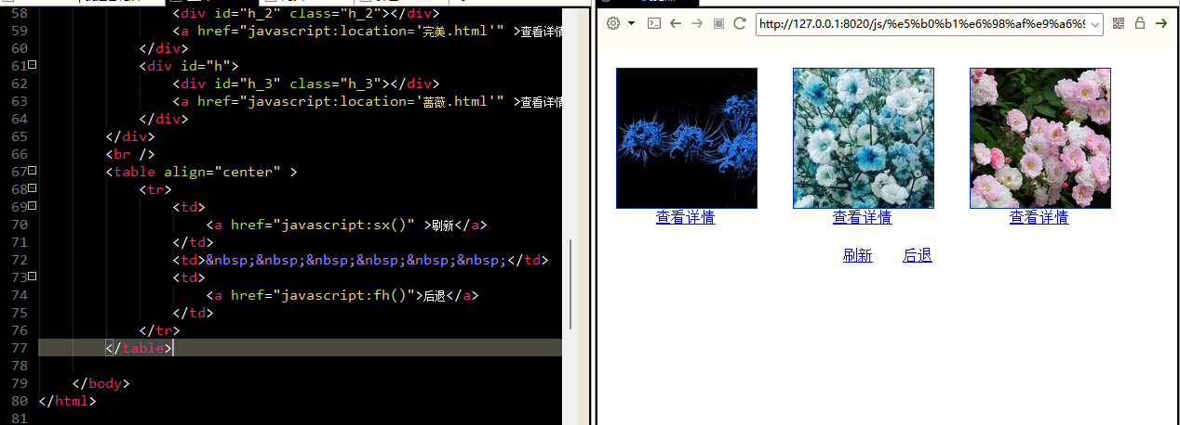
克莱因-彼岸
<!DOCTYPE html>
<html>
<head>
<meta charset="UTF-8">
<title></title>
<style>
body{
margin: 0;
padding: 0;
}
div{
width: 200px;
height: 200px;
border: 1px solid;
border-color:rgb(0, 47, 167);
float: left;
margin: 10px 10px 10px 10px;
padding: 10px 10px 10px 10px;
background-image: url(img/KELAIYIN.jpg);
background-size: 300px;
}
</style>
<script>
function qj(){
window.location.go(1);
}
function ht(){
window.history.go(-1)
}
function tc(){
window.open("直播.html","","height=300,width=400");
}
function tz(){
window.location="购买.html"
}
function tan(){
open("弹窗.html","height=100,width=400")
}
</script>
</head>
<body onload="tan()">
<div>
</div>
<table>
<tr><br/></tr>
<tr></tr>
<tr>
<td colspan="6">商品名称 ：克莱因-彼岸</td>
</tr>
<tr></tr>
<tr>
<td colspan="6">特点: 神秘 幽远</td>
</tr>
<tr></tr>
<tr>
<td colspan="6">用途: 送朋友，自我欣赏</td>
</tr>
<tr></tr>
<tr>
<td colspan="6">花语: 理想</td>
</tr>
<tr></tr>
<tr>
<td colspan="6">价格: $99999</td>
</tr>
<tr></tr>
<tr>
<td colspan="6">产地: 墓</td>
</tr>
<tr></tr>
<tr>
<td colspan="6">编号:000000</td>
</tr>
<tr></tr>
<tr>
<td>
<a href="javascript:tc()">直播</a>
</td>
<td>&nbsp;&nbsp;&nbsp;&nbsp;&nbsp;&nbsp;</td>
<td>
<a href="javascript:tz()">购买</a>
</td>
<td>&nbsp;&nbsp;&nbsp;&nbsp;&nbsp;&nbsp;</td>
<td>
<a href="javascript:qj()" >前进</a>
</td>
<td>&nbsp;&nbsp;&nbsp;&nbsp;&nbsp;&nbsp;</td>
<td>
<a href="javascript:ht()">后退</a>
</td>
</tr>
</table>

</body>
</html>
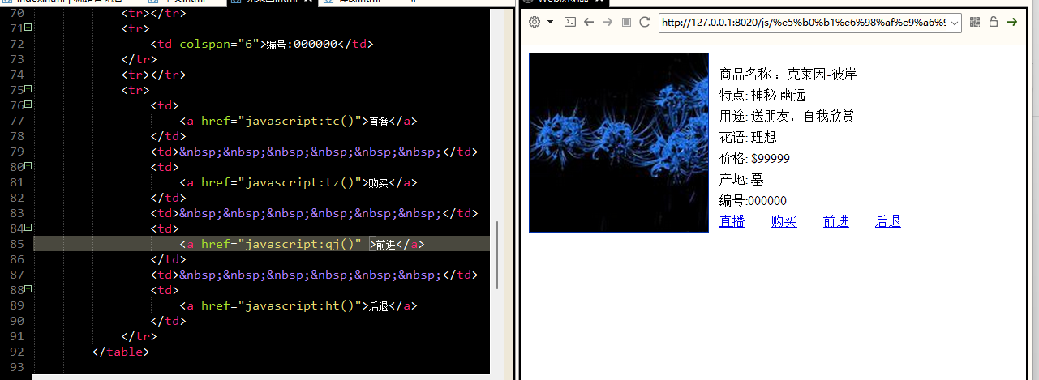

完美-满天星
<!DOCTYPE html>
<html>
<head>
<meta charset="UTF-8">
<title></title>
<style>
body{
margin: 0;
padding: 0;
}
div{
width: 200px;
height: 200px;
border: 1px solid;
border-color:rgb(0, 47, 167);
float: left;
margin: 10px 10px 10px 10px;
padding: 10px 10px 10px 10px;
background-image: url(img/wanmei.png);
background-size: 300px;
}
</style>
<script>
function qj(){
window.location.go(1);
}
function ht(){
window.history.go(-1)
}
function tc(){
window.open("直播.html","","height=300,width=400");
}
function tz(){
window.location="购买.html"
}
</script>
</head>
<body>
<div>
</div>
<table>
<tr><br/></tr>
<tr></tr>
<tr>
<td colspan="6">商品名称 ：完美-满天星</td>
</tr>
<tr></tr>
<tr>
<td colspan="6">特点: 舒缓 清新</td>
</tr>
<tr></tr>
<tr>
<td colspan="6">用途: 送朋友，恋人，同学</td>
</tr>
<tr></tr>
<tr>
<td colspan="6">花语: 自由 诚信</td>
</tr>
<tr></tr>
<tr>
<td colspan="6">价格: $999</td>
</tr>
<tr></tr>
<tr>
<td colspan="6">产地: 新疆</td>
</tr>
<tr></tr>
<tr>
<td colspan="6">编号:000001</td>
</tr>
<tr></tr>
<tr>
<td>
<a href="javascript:tc()">直播</a>
</td>
<td>&nbsp;&nbsp;&nbsp;&nbsp;&nbsp;&nbsp;</td>
<td>
<a href="javascript:tz()">购买</a>
</td>
<td>&nbsp;&nbsp;&nbsp;&nbsp;&nbsp;&nbsp;</td>
<td>
<a href="javascript:qj()" >前进</a>
</td>
<td>&nbsp;&nbsp;&nbsp;&nbsp;&nbsp;&nbsp;</td>
<td>
<a href="javascript:ht()">后退</a>
</td>
</tr>
</table>
</body>
</html>
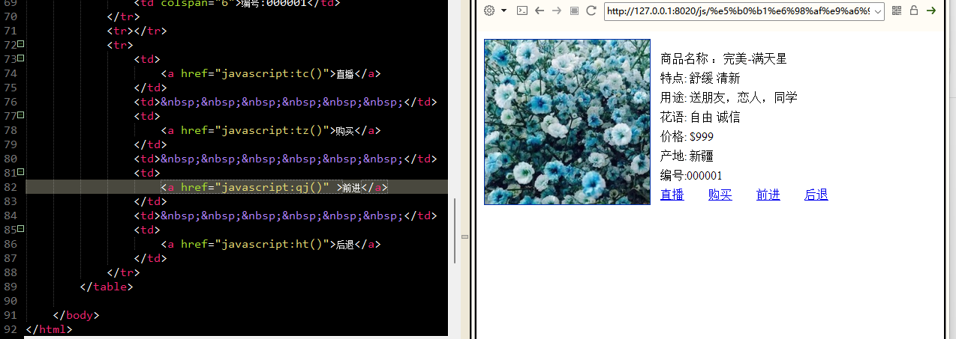

偕老-蔷薇
<!DOCTYPE html>
<html>
<head>
<meta charset="UTF-8">
<title></title>
<style>
body{
margin: 0;
padding: 0;
}
div{
width: 200px;
height: 200px;
border: 1px solid;
border-color:rgb(0, 47, 167);
float: left;
margin: 10px 10px 10px 10px;
padding: 10px 10px 10px 10px;
background-image: url(img/qiangwei.jpg);
background-size: 300px;
}
</style>
<script>
function qj(){
window.location.go(1);
}
function ht(){
window.history.go(-1)
}
function tc(){
window.open("直播.html","","height=300,width=400");
}
function tz(){
window.location="购买.html"
}
</script>
</head>
<body>
<div>
</div>
<table>
<tr><br/></tr>
<tr></tr>
<tr>
<td colspan="6">商品名称 ：偕老-蔷薇</td>
</tr>
<tr></tr>
<tr>
<td colspan="6">特点: 温暖 爱意</td>
</tr>
<tr></tr>
<tr>
<td colspan="6">用途: 送恋人</td>
</tr>
<tr></tr>
<tr>
<td colspan="6">花语: 思念 誓言</td>
</tr>
<tr></tr>
<tr>
<td colspan="6">价格: $999</td>
</tr>
<tr></tr>
<tr>
<td colspan="6">产地: 分布广泛</td>
</tr>
<tr></tr>
<tr>
<td colspan="6">编号:000002</td>
</tr>
<tr></tr>
<tr>
<td>
<a href="javascript:tc()">直播</a>
</td>
<td>&nbsp;&nbsp;&nbsp;&nbsp;&nbsp;&nbsp;</td>
<td>
<a href="javascript:tz()">购买</a>
</td>
<td>&nbsp;&nbsp;&nbsp;&nbsp;&nbsp;&nbsp;</td>
<td>
<a href="javascript:qj()" >前进</a>
</td>
<td>&nbsp;&nbsp;&nbsp;&nbsp;&nbsp;&nbsp;</td>
<td>
<a href="javascript:ht()">后退</a>
</td>
</tr>
</table>
</body>
</html>
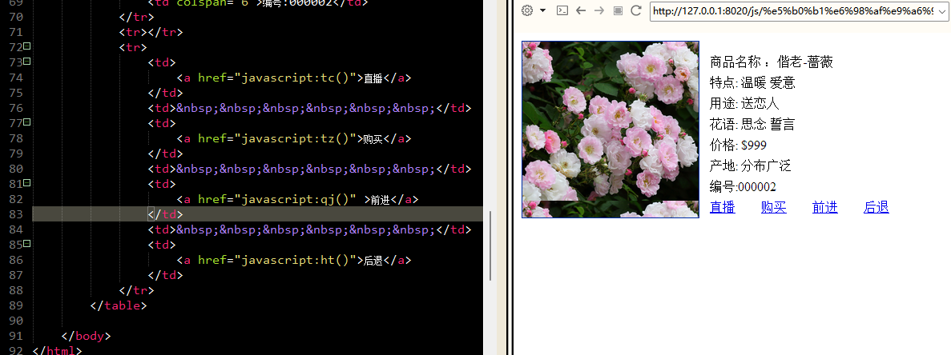

购买页
<!DOCTYPE html>
<html>
<head>
<meta charset="UTF-8">
<title></title>
</head>
<script>

function get(){
//数量
var sl=document.getElementById("sl").value

document.getElementById("zj").innerText=Number(sl)*999
}
function get_1(){
var d=confirm("您确定要购买么?")
if (d) {
alert("购买成功！\n欢迎下次光临.")

}else {
alert("不买后悔一辈子")
}
}
function ht(){
window.history.go(-1)
}
</script>
<body>
<form >

数量:<input type="text" id="sl"/><br />
单价:<span >999</span><br />
总金额:<span id="zj">0</span><br />
<input type="button" onclick="get()" value="提交"/>
<input type="button" onclick="get_1()" value="购买"/>
<input type="button" onclick="ht()" value="后退"/>
</form>
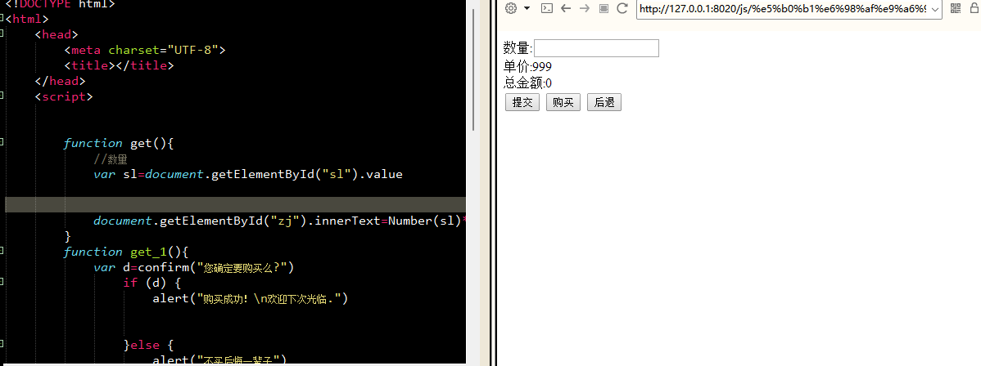

弹窗
<!DOCTYPE html>
<html>
<head>
<meta charset="UTF-8">
<title></title>
<script>
function getDate() {
var d = new Date();
var year = d.getFullYear()
var month = d.getMonth() + 1
var data = d.getDate()
var hour = d.getHours()
var Minute = d.getMinutes()
var Second = d.getSeconds()

document.getElementById("msg").innerHTML = year + "-" + month + "-" + data
+ " " + hour + ":" + Minute + ":" + Second
}
var s=setInterval("getDate()",1000);
</script>
</head>
<body onload="getDate()">
<div id="msg">

</div>
<span style="color:red; font-size: 20px;">有什么可以帮助您的</span>
</body>
</html>

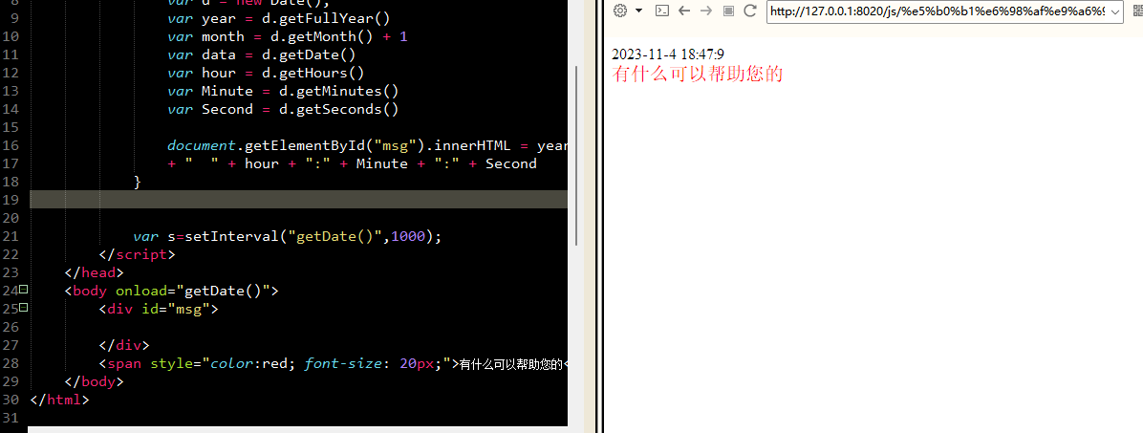

弹窗截图


